**1 INTRODUCTION**

* 1. Overview

**Implementing CRM for Result tracking of a candidate with internal marks**

Our topic is based on customer and office relationship. And also implementing a relationship between them. Here the topic is on internal marks of a candidate.

1.2 Purpose

By implementing the Customer Relationship Management we can have a wavelength with the customers to solve their problems and fulfill their needs.

1. **Problem Definition & Design Thinking**

2.1 Empathy Map

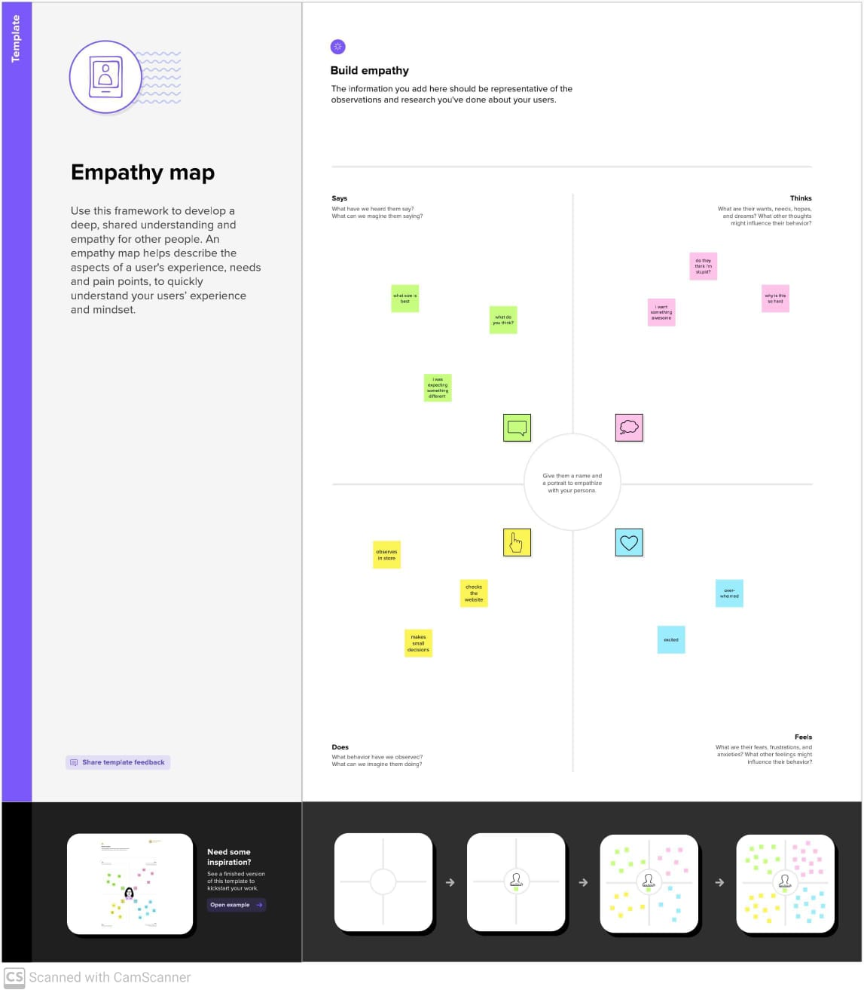

2.2 Ideation & Brainstorming Map

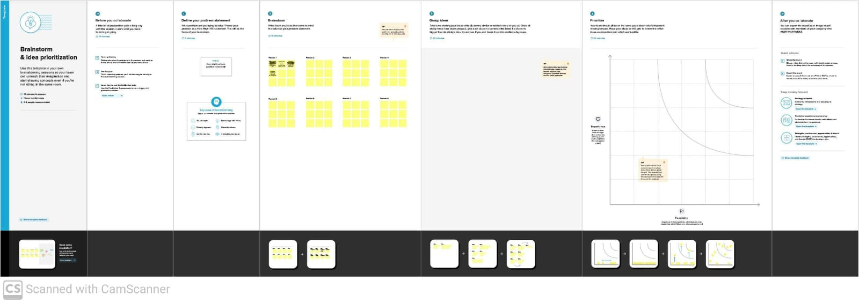

**3 RESULT**

**3.1** Data Model

|  |  |
| --- | --- |
| **Object name** | **Fields in the Object** |
| Object 1 | |  |  | | --- | --- | | Field Label | Data Type | | Semester | Text | |
| Object 2 | |  |  | | --- | --- | | Field Label | Data Type | | Candidate | Text | |
| Object 3 | |  |  | | --- | --- | | Field Label | Data Type | | Course Details | Text | |
| Object 4 | |  |  | | --- | --- | | Field Label | Data Type | | Lecturer Details | Text | |
| Object 5 | |  |  | | --- | --- | | Field Label | Data Type | | Internal results | Text | |

**3.2 Activity & Screenshot**

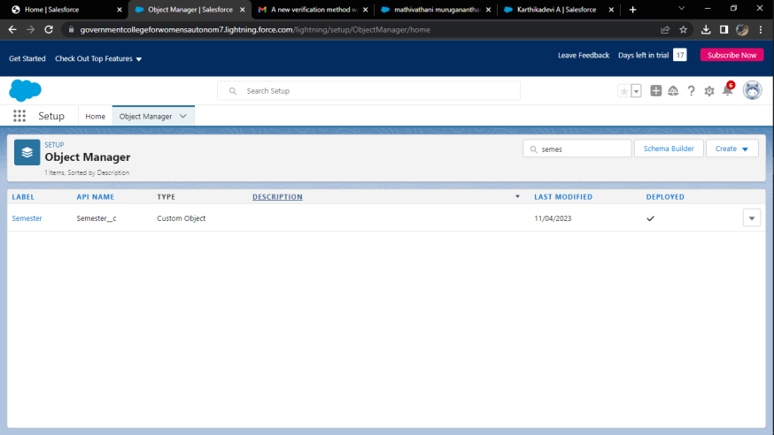

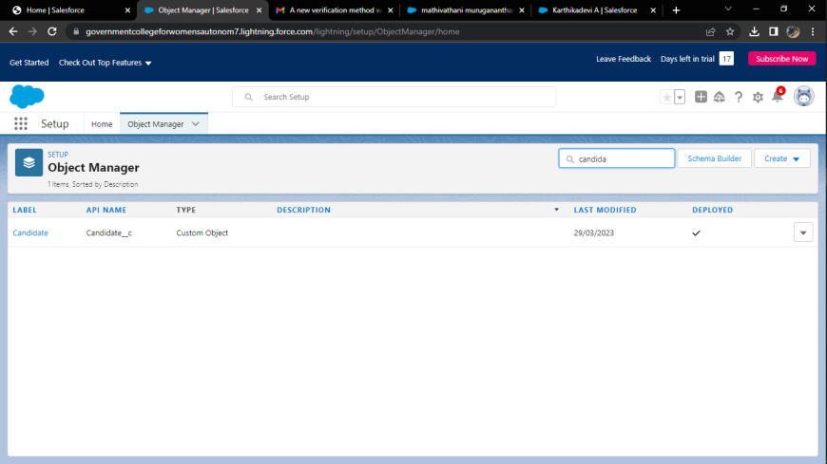

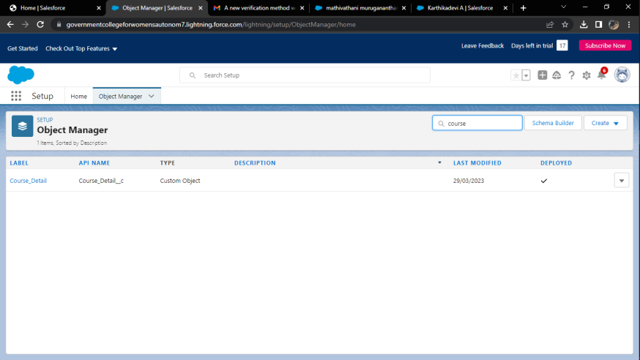

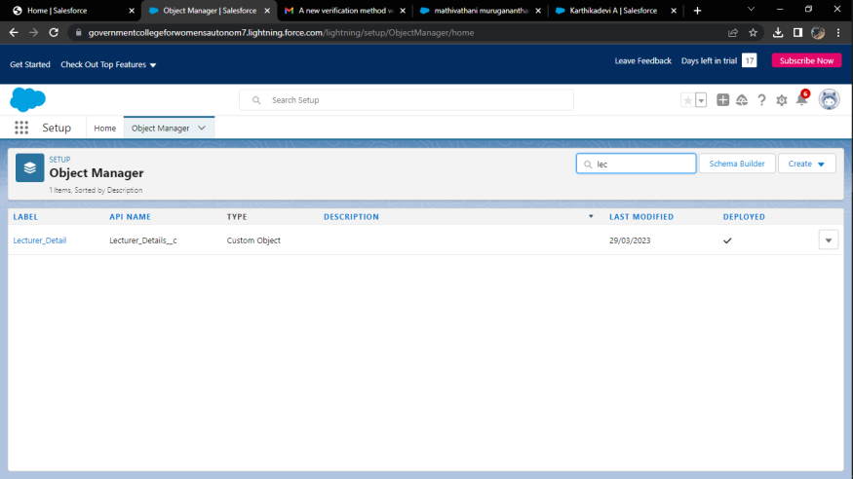

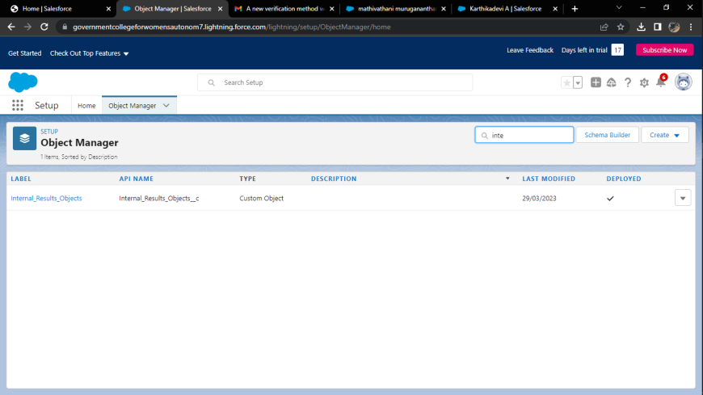

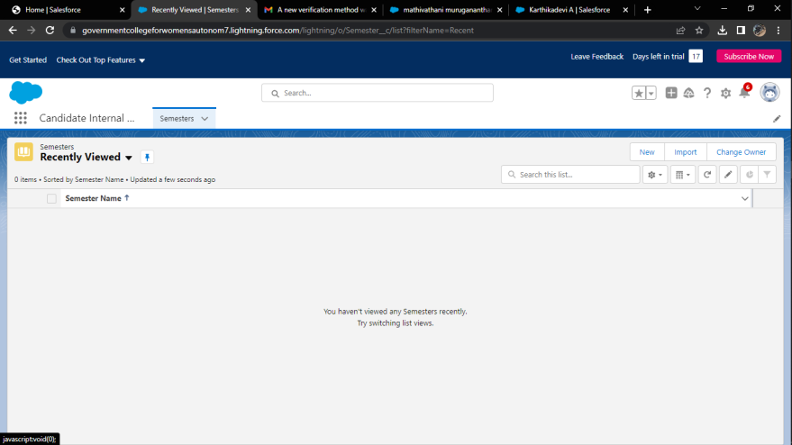

**4 Trailhead Profile Public URL**

Team Lead - <https://trailblazer.me/id/mathivathani3129>

Team Member 1 - <https://trailblazer.me/id/karta42>

Team Member 2 - <https://trailblazer.me/id/kselvakumar7>

Team Member 3 – <http://trailblazer.me/id/mmathi102>

**5 ADVANTAGES**

By this project we can easily sort out each and every customer and we can satisfy their needs.

**DISADVANTAGE**

Also we are on online so we cannot get an personal need of the customers individually and we are not able to implement life testing upgrades.

**6 APPLICATIONS**

Mainly these were applicable in most IT’s were the count of people is huge and can implement their needs.

**7 CONCLUSION**

Hereby we are concluding that, implementing CRM is a wide way in the internet to explore their thoughts.

**8 FUTURE SCOPE**

Most wide in oru modern world online platform is playing an important role. So, in future the purpose using this will be huge.